[**CIS6930/4930**](http://www.cise.ufl.edu/~helal/classes/s13/index.html) **- Spring 2013**

**Professor – Sumi Helal**

**Shravan Pentamsetty 9862-5845** [**shravansetty@ufl.edu**](mailto:shravansetty@ufl.edu) **Nyshadh Reddy R 1911-3564** [**nyshadh.reddy@ufl.edu**](mailto:nyshadh.reddy@ufl.edu)

**Srinivas Balaji Ramesh 9421-7395** [**rsbalaji@ufl.edu**](mailto:rsbalaji@ufl.edu)

**Mobile Platforms & Development Environments**

**E - Contacts**

Table of Contents

1.The Idea and Motivation 2

2. App design 4

3. Implementation 5

4. Network resources used 6

5. PROJEct status 6

6. Materialized team effort 7

7.Video (Optional) 7

8.planned Future Improvements 7

# The Idea and Motivation

Have you ever thought of being in a situation where you are in trouble or you saw someone in your vicinity in a trouble like an accident – fire, vehicle etc. and you are looking to contact the nearest rescue service to help you to get out of this tough situation without any hassle?

Any normal human would try to contact the required rescue service for help or he would like to let his contact know about his situation so that they might be of help. In this case, it is quiet possible that you are very tensed and are in a shock and you cannot communicate effectively to explain your position.

To avoid such a situation, we planned to come out with an application, which helps any individual to immediately contact the nearest police station/hospital/ambulance service/fire station by acting appropriately and getting the contact details of them. It is often to see a road accident wherein there is a huge blood loss and is in need of blood, which is an emergency. We planned to incorporate a feature called “Blood Bank” which will enable a user to send a message to all his contacts regarding the place where he is located and the type of blood that is required.

We also planned to implement text messaging to 911. As of now, we cannot send text messages to 911. Government is rigorously working on this and the feature will be available pretty soon. We will be taking this feature to be a part of further improvements, which is covered, in the later part in the report.

The bottom line is that the main idea behind this project was to create an android application that could be of great use in times of emergency. Our goal is to help set an official guideline to assist Emergency Response Teams in their efforts to save time and lives in the event of an emergency and help people in times of emergency. There would also be functionalities that would allow quick access to all relevant information that would be required at the times of an emergency. Thus, with only one click on your screen, we can send SMS alerts to all your saved contacts, call rescue workers. Thus, this application could be a **LIFE SAVER** in times of a calamity.

As discussed, this application would be very helpful in case of calamities where every second counts.

Various situations wherein you can use this application:

- House is on fire

- Robbery

- Car Crash/Accidents

- Cases of Harassment

- Domestic Abuse

- Missing Person (kidnapping)

- Massacre and many more.

The other interesting part is that, people with speech disorders can use this application since they are just few taps away to communicate the problem. In this crazy world with amazing technology, everyone is using tablets. People with android tablets can install our application and save their lives themselves without depending on others.

Tap Shield or Campus Shield is a similar app, which has been developed by a group of local developers from Gainesville. This app informs campus police authorities about the current location of a student who might be in a spot of bother. The basic motive of both E-contacts and Campus Shield may look similar - that of sending out a distress signal, but our app tries to reach out to your near ones because the authorities are always a call away (911). We feel that in times of emergency it would be really helpful if a person could send a signal to his personal contacts in addition to alerting the concerned authorities. The other major differentiating factor is that our app sends out any nearby blood bank or ambulance services information to the emergency contacts, which will be of great help in times of accidents.

# 2. App design

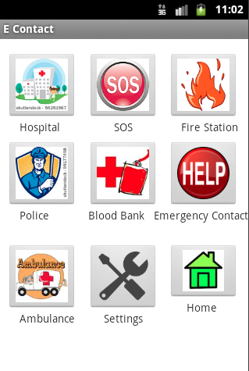

Here are few high-level details of our application:

1) Whenever you install the application for the first time, it is mandatory to enter your details and register yourself by providing your name, contact number, blood group, emergency contact name and emergency contact number.

2) An option to update your and your emergency contact details is provided in the application under the “Settings” option. Incase you want to give your phone to someone, they can update their corresponding details instead of uninstalling and installing the app again.

3) Feature to contact the emergency contact number is provided under “Help” option.

4) Feature to contact rescue hotlines is provided under “SOS” session.

5) Option to send a request for blood group by sending an SMS to all the contacts, which includes the current location of the user, blood group required is possible with the “Blood Bank” feature.

6) Nearest hospitals, Ambulance Service, Fire Station, Police Stations available can be searched using the corresponding options provided in our application.

# 3. Implementation

**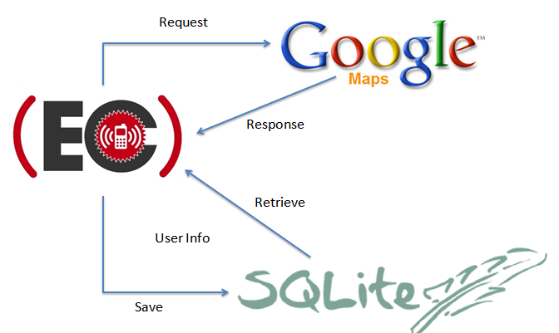**

The architecture we have used is well described in the above picture.

We have developed the application incrementally to make sure we have a working app at all times. Even when we were unable to provide the maps for the demo, we had a running app without app. We finally made a working final version with maps. Also, distributing and implementing the app was managed very effectively so that there are less conflicts and regressions introduced in our app. We strongly believed in submitting an app with less features but fully functioning one rather than the one with more features and an unstable version. At the end, we provided a stable version of the app with all the features promised.

The project involved the use of SQLLite as the database for storing information. It implements a self-contained, server less, zero-configuration, transactional SQL database engine. Android simulator was used to check the working of the application and the app was checked for compatibility with API 10 as the target API. Google maps API is used to locate the co-ordinates of the nearest service points. The below is the description of how the modules that were used in the App Design interact to produce the desired result.

The registration module is used to collect user details as well as the emergency contacts information and stores them. The maps module dynamically retrieves location co-ordinate information from the google maps API. The other modules dynamically retrieve location from the google maps server and use them to provide related information to the user with respect to the service the user has requested. There are other features like the broadcast blood donation request that broadcast bulk SMSs to all the emergency contacts in the user’s database.

# 4. Network resources used

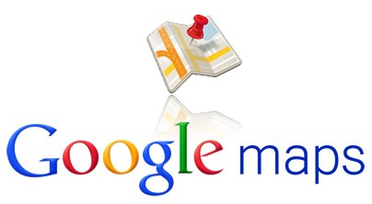

We have used “Google Maps Android API v2” to get the corresponding information of maps. We are fetching longitude, latitude and are executing query to get the results of required information. We are adding markers to the map that is shown based on the type of service selected from the home screen.

Steps:

1. To obtain API Key for Google Maps Android API v2 service, you have to create API Project and obtain your API Key in Google APIs Console.
2. To obtain your Android API Key, we need to use SHA1 Certificate fingerprint value from the key store used to build the apk.
3. The Android key obtained from Google API Console needs to be updated in the manifest.xml to be able to access the maps.
4. The project needs to be of the type “Google API”.
5. We need to add all the relevant permissions to access internet and to fetch the locations.

# **5.** PROJEct status

Though there were glitches to make the maps run on a mobile, we tried our best and all the hard work paid off. We are able to show the maps, recorded a video, uploaded it to “youtube” and we included the same in the project report. We managed to complete the project within the deadline and mostly importantly – the working version. As far as we tested, we did not encounter any issues and the app runs absolutely fine on any android device with API Version >=10.

# 6. Materialized team effort

|  |  |  |  |  |
| --- | --- | --- | --- | --- |
| **Name** | **Idea** | **Design** | **Implementation** | **Reporting** |
| ***Shravan*** | 40% | 30% | 35% | 35% |
| ***Nyshadh*** | 35% | 30% | 35% | 35% |
| ***Srinivas*** | 25% | 40% | 30% | 30% |

# 7.Video (Optional)

The video is optional. As we were able to fix the ANDROID API Key issue we had during the final presentation and got the maps running in the last minute, we managed to take the demo video and are uploading the same. One can view the Video using the following given hyperlink. [http://www.youtube.com/watch?v=HNnN1F2QhPA&feature=youtu.be](http://www.youtube.com/watch?v=HNnN1F2QhPA&feature=youtu.be" \t "_blank)

Video of Maps:

<http://www.youtube.com/watch?v=coPKKUmQZIg&feature=youtu.be> <http://www.youtube.com/watch?v=_S2iF_nLB1o&feature=youtu.be>

# 8.planned Future Improvements

As suggested by the professor, we will be improving the application by getting the hotline numbers dynamically based on the location in which the user is present. With this feature incorporated, it would easy for customer outside USA to use our application. As part of further development, we are also planning to incorporate a feature to send a text message to 911.